Sorting information into groups, decision making and creating Venn Diagrams

Audience:

This activity can be used for groups and individuals of all levels. Learners who are not native English speakers may need support to understand the concepts of sorting and some of the decisions that need to be made, but this type of activity will help to develop English skills as well as maths.

Sorting is a key basic skill that is needed at pretty much every level within maths, and it's important that people understand what the concept of sorting is and how you can arrive at the criteria that can establish a category.

This resource is aimed at groups of learners, best delivered in a face-to-face class or a group setting (for learners with lower levels of ability); or developed into an online format (for more confident learners) by using an online noticeboard or whiteboard for the groups to be able to work together to allow them to discuss and complete the tasks.

While the tasks within this resource are very straightforward, further development could extend the mechanics of sorting into more complex aspects of maths and easily connect with vocational themes and add deeper meaning and relevance.

Purpose:
Build confidence with making decisions that involve a range of different things and understanding the concepts of grouping and categories.
Can also be used as a group task to build collaboration, communication and team building, as well as decision making and basic problem solving.

Value:

Grouping things via categories or criterion is a fundamental mathematical skill often taken for granted. Venn Diagrams are straightforward when understood well and the approach used to build the knowledge and understanding for this aspect of maths follows a logical approach that demystifies some of the common misconceptions.

If used in a group setting this resource also involves discussion, agreement and collaboration, as well as collective decision making.

The Activity set up explained:

The materials needed for this activity are:

A selection of chocolates, that contain milk, plain, hard and soft centres and some with nuts.

You will also need other items that you can sort, for example coloured counters, marbles, different shapes etc. The number of things to be sorted is likely to be defined by what you feel your group will need. If your learners are of a lower-level ability or language is a barrier and you feel understanding could be an issue, then more categories would be appropriate.

In addition templates and cards, that could be printed on paper

Card set A - numbers - one for each group

Sheet 1 – Sorting grid. One copy per pair or group.

Sheet 2 - Blank sorting grid . One copy per pair or group.

Consider one copy of this grid per different item that you want the learners to sort, if you're having multiple items to be sorted and you want your learners to write on the grids. For learners who are not native English speakers, writing items into the grids can provide additional practice with language development and you may want to issue one blank grid per learner.

Sheet 3 – Two-way Venn diagram. One copy per pair or group.

Sheet 4- Three-way Venn diagram. One copy per pair or group.

Task 1

Put learners into pairs or small groups and give each pair/ group a copy of

Sheet 1– Sorting Grid

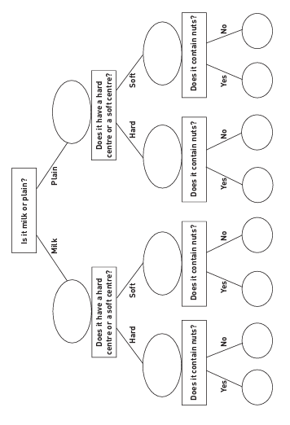
And a pile of chocolates.
Sheet 1– Sorting grid

Set up the task by explaining that they are to take one sweet at a time and move it through the grid by answering the questions, until it reaches the bottom row.

Facilitate completion of the task

When the learners have finished, ask the pairs/ groups to compare results with each other and see/ discuss, which sweets have ended up in which position.

Ask them to describe the characteristics of each set of sweets.

This could be as a whole group on between groups, depending on the make-up and confidence levels of the learners overall.

Encourage wider discussions on differences, such as: If there was something

like a toffee in the pile then it will not have a route to go down;

this makes an interesting discussion point and builds on the learning taking place.

Task 2
Sheet 2– Blank sorting grid
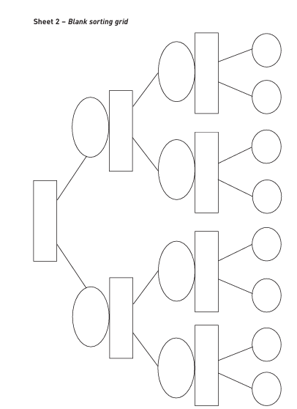

To develop this further, give learners something else to sort (this could be something you have chosen/ prepared or let them choose for themselves)

Suggestions are: biscuits, shapes, adverts from magazines, coins or anything that has variety and is of interest to the learners.

Ask the learners to construct a sorting grid for their items,

using Sheet 2– Blank sorting grid.

When they have finished, ask them to pass it to another pair of learners for checking.

Alternatively, learners could be given a sorting grid with answers written in the bottom row and be asked to write in what the questions would be.

This could be done using numbers, shapes or any type of object that has variety.

Task 3
Card set A– Numbers

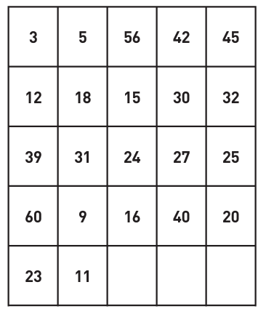

Depending on the make up of the group, this could be a good opportunity to mix pairs/ groups up

This next task is also for pairs or small groups

Once the pairs/ groups have been established

Give each group Card set A– Numbers.

Explain that the task is for learners to sort the cards into two sets, using any binary criterion they choose

Their choice is “does the number satisfy or not satisfy their criteria?”

When the task has been completed, ask each pair/group to explain how they have sorted their cards, to another pair/group

What criteria did they use?

Then ask each pair to suggest another number they could add to one of the sets using the same criterion.

Writing it on one of the blank cards and adding it to their sort.

An alternative is to repeat the exercise, asking learners to use a different criterion and, again, to explain it and to suggest another number or numbers.

If learners are unable to choose a criterion to use some ideas for suggestions are:

Numbers less than or more than 30;

odd and not odd (even) numbers;

prime and not prime;

divisible and not divisible by 3;

and so on.

Next, still using Card set A- Numbers, ask the learners to sort according to two criteria – for example, (i) numbers less than 30, (ii) even numbers.

The intention here is to get them to do a two stage, or double sort of the numbers, not put them into two different groups.

While facilitating the task circulate around the groups and listen to some of the discussions, note, but do not address any inaccuracies or misconceptions.

Make a note of what was said and draw this out in whole group discussions when the task has been completed.

Alternatively: when they realise that some numbers satisfy both criteria, and some neither, encourage them to explain how they could show this in their sorting.

Whole Group Discussion
Ask one group to show everyone how they sorted according to their chosen two criteria.
Encourage other learners to question them on their representation.
Discuss until everyone is clear that some numbers satisfy only one of the criteria, some both, and some neither.
If you need to you could help shape the thinking by asking:
How did you decide where on the table to put each number?

How many groups did you think you would end up with?
Did anything surprise you about this task?
What problems did you have?
How did you solve them?
You should explain that what they have done is discovered Venn diagrams.
Show them, if they have not represented it exactly like this, that their solution could be put into a diagram of two overlapping circles on a whiteboard or flip chart.
Label the diagram according to the two categories and add the numbers to the Venn Diagram following the group choices

The completed diagram might look something like this
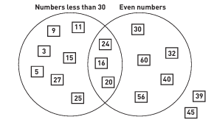

When completing this part of the session make sure that everyone understands the reason why there are some numbers in the middle and some outside.
You could ask further questions such as:
Give a definition for the numbers in the overlap section.
Add some more numbers.
Give a definition of the numbers which fall outside the circles.
Add some more numbers.

Give a description for the numbers in the left hand circle which are not in the overlap.
Add some more numbers.
In this way learners will be able to write down descriptions of each set within the Venn diagram.
In a two-way diagram there will be four such sets.
This gives the learners the opportunity to use their existing knowledge about types of numbers.
For example, in the example, numbers in the intersection set could be described as ‘even numbers less than 30’.

Task 4
Issue Sheet 3 to each group
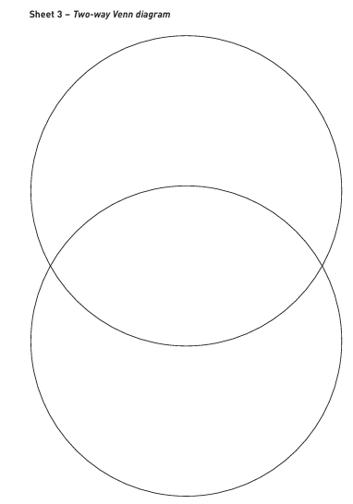
Sheet 3 – Blank 2 way Venn Diagram

The task is to transfer the categories they chose for the simple sort to the Venn Diagram template and add the numbers from their double sort to the grid in the correct place
Facilitate completion

When they have put all the numbers in place there may be some intersections that have no number (depending on which criteria they have chosen).
Ask them to think of a number that could go there, or to give an explanation as to why there cannot be a number there.

Task 5
Depending on the ability of the group
Next, ask the pairs of learners to either choose two more criteria or repeat the exercise,
or choose three criteria and create a three-way Venn diagram to sort the numbers in Card set A.
Learners may find it helpful to use either Sheet 3– Two-way Venn diagram or Sheet 4– Three-way Venn diagram to help with the sorting.
If they choose the second option they may again have the problem of what to do with numbers that fit more than one of their sets.
When they have completed this task they could again write down descriptions for each of the four sets formed by the two-way, or each of the eight sets formed when completing the three-way Venn diagram.
Then to bring everything together
Ask learners in pairs or small groups to think of their own items for sorting, and to use either a two-way or a three-way Venn diagram to do so.
They may, use characteristics of the members of their class, or a list of films, or a pile of coins.
Listen as they discuss what two or three criteria they are going to select, and how to sort the items according to these.
They could challenge other pairs or groups to work out what sorting criteria have been used.

Sheet 1– Sorting grid

Sheet 2– Blank sorting grid

Card set A– Numbers

Sheet 3 – Blank 2 way Venn Diagram

Sheet 4 – Blank 3 way Venn Diagram

